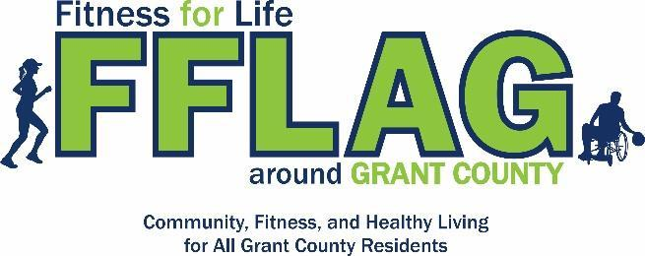
Community Outreach Funds Program
Request for Funding

Fitness For Life Around Grant County is committed to supporting community and school events/projects focusing on healthy lifestyles. FFLAG is currently accepting proposals from Grant County organizations to support the initiation or continuation of public health infrastructure projects, events or campaigns.

Please complete the application below for your event/project to be considered for funding.

To be considered for funding, a representative from your organization must have participated in at least two Fitness For Life Around Grant County events or meetings within the last twelve months. All applications must be submitted and approved prior to the event/project occurring. All applications must be submitted via email to GetFitGrantCounty@gmail.com by 5:00 pm on the application deadline date. Applications received after the deadline will not be accepted. All applications will be reviewed by the FFLAG Executive Board for scoring and consideration.

Funding Cycle:
Proposal Announcement: October 23, 2023
Application Deadlines: December 7, 2023
Notification of Award: December 29, 2023
Final Project Report Due: December 29, 2024

Events/projects selected for funding will be asked to have youth participants, complete a final project report, make available education materials provided by the coalition, and acknowledge FFLAG on all media and signage.

Events/projects selected for funding must be completed within 1-year of award.

Organization Name: ____________________________________________________________________

Main Contact Person Name & Title: ________________________________________________________

Street Address: ________________________________________________________________________

Phone: _________________________________ Email: _______________________________________

Additional Contacts (Please provide name & email): _____________________________________________________________________________________

_____________________________________________________________________________________

Event/Project Title: ____________________________________________________________________

Event/Project Date: ____________________________________________________________________

Amount Requested (Up to $5,000): _________________________________________________________

Number of youth participating: ___________________________________________________________

Number of adults participating: ___________________________________________________________

Applicant was awarded during the previous cycle (Dec 2022) _____ YES _____NO

If YES above, please answer the following:

This application is a continuation/enhancement of the previously awarded project _____ YES _____NO

Involvement with FFLAG: (10 Points)
Describe your involvement with FFLAG over the past 12 months.

Event/Project Description and Timeline (20 Points)
Describe the project, goal for the project and activities, and how it will impact the community. Provide a brief timeline for implementation over 12 months.

Community Partnerships/Collaborations (20 Points)
Please include all community partnerships or collaborations related to this project and how they will contribute to the overall project.

Communication and outreach (10 Points)
Please include a description of planned outreach and communication, along with your website and social media links for us to follow.

Health Equity Contribution (20 Points)
Using the Seven Strategies to Affect Community Change listed on page 4, please describe how this
activity will help achieve this community-level change.

Budget: (20 Points)
Provide a detailed budget with clear expense description, justification of expenses and in-kind contributions.
Expense Description | Amount Requested from FFLAG | In-Kind
Total Expenses

Justification of Expenses:

Seven strategies for community change: A brief explanation

Each of these strategies represents a key element to build and maintain a healthy community. In the planning process, utilize all seven strategies to be as comprehensive as possible to achieve population-level change. When focusing on implementation of environmental strategies, consider the types of information, skill-building and support activities necessary to move your interventions forward. You will see that the strategies overlap and reinforce each other.

Seven strategies to affect community change
1. Provide information—Educational presentations, workshops or seminars, and data or media presentations (e.g., public service announcements, brochures, billboard campaigns, community meetings, town halls, forums, web-based communication).
2. Enhance skills—Workshops, seminars or activities designed to increase the skills of participants, members and staff (e.g., training, technical assistance, distance learning, strategic planning retreats, parenting classes, model programs in schools).
3. Provide support—Creating opportunities to support people to participate in activities that reduce risk, enhance healthy lifestyles (e.g., providing alternative activities, mentoring, referrals for services, support groups, youth clubs, parenting groups).
4. Enhance access/reduce barriers**—Improving systems and processes to increase the ease, ability and opportunity to utilize systems and services (e.g., access to treatment, childcare, transportation, housing, education, special needs, cultural and language sensitivity).
5. Change consequences (incentives/disincentives)—Increasing or decreasing the probability of a specific behavior that reduces risk or enhances protection by altering the consequences for performing that behavior (e.g., increasing public recognition for deserved behavior, individual and business rewards, taxes, citations, fines, revocations/loss of privileges).
6. Change physical design—Changing the physical design or structure of the environment to reduce risk or enhance protection (e.g., parks, landscapes, signage, lighting, outlet density).
7. Modify/change policies—Formal change in written procedures, by-laws, proclamations, rules or laws with written documentation and/or voting procedures (e.g., workplace initiatives, law enforcement procedures and practices, public policy actions, systems change within government, communities and organizations).

**Note: This strategy also can be utilized when it is turned around to reduce access/enhancing barriers. When community coalitions establish barriers to underage drinking or other illegal drug use, they decrease its accessibility. Prevention science tells us that when more resources (money, time, etc.) are required to obtain illegal substances, use declines. When many states began to mandate the placement of pseudoephedrine-based products behind the pharmacy counter, communities experienced a significant decrease in local clandestine methamphetamine labs. Barriers were put into place that led to a decrease in the accessibility of the precursor materials for meth production.

Community Anti-Drug Coalitions of America. National Community Anti-Drug Coalition Institute.
The Coalition Impact: Environmental Prevention Strategies. 2010. http://www.cadca.org/sites/default/files/resource/files/environmentalstrategies.pdf

